Heaven's light is our guide
Rajshahi University of Engineering & Technology

Department of Computer Science & Engineering



Sessional (Lab Report)-01

Course Name : Data Communication Sessional
Course Code : CSE 3204
Experiment No : 01
Experiment Name : Analog to Analog Signal-Amplitude & Frequency
Modulation & Demodulation.
Date of Experiment : 29 Nov, 2025
Date of Submission : 03 Jan, 2026

Submitted by:  Roll Name  2103061 Md. Mushfiqur Rahman  2103062 Md. Rraf Hasan  2103063 Md. Raiyan Haque Ashwas  2103064 Md. Asad-Al-Adil  2103065 Md. Morakib Hossain  2103066 Md. Akibul Hasan | Submitted to:  Shyla Afroge  Associate Professor  Department of Computer Science and Engineering, RUET

1.Experiment name:
Analog to Analog Conversion using Amplitude Modulation and Demodulation

Objective:
- This experiment explores how amplitude modulation (AM) works.
- We will see how an audio signal changes a high-frequency wave (modulation) and then how to get that original audio signal back (demodulation).

Theory:
Amplitude Modulation (AM) is a process where the amplitude (strength) of a high-frequency carrier wave is adjusted to match the immediate level of an input (message) signal. Only the carrier's amplitude changes, not its frequency or phase.
This method is commonly used in communications, especially for long-distance audio transmission in radio broadcasting. The modulated signal carries the information in its amplitude, allowing the receiver to reconstruct the original message.
Demodulation is the reverse of modulation, where the receiver extracts the original message from the carrier wave. This essential process ensures the information is recovered accurately for reliable communication.

Pin connections:
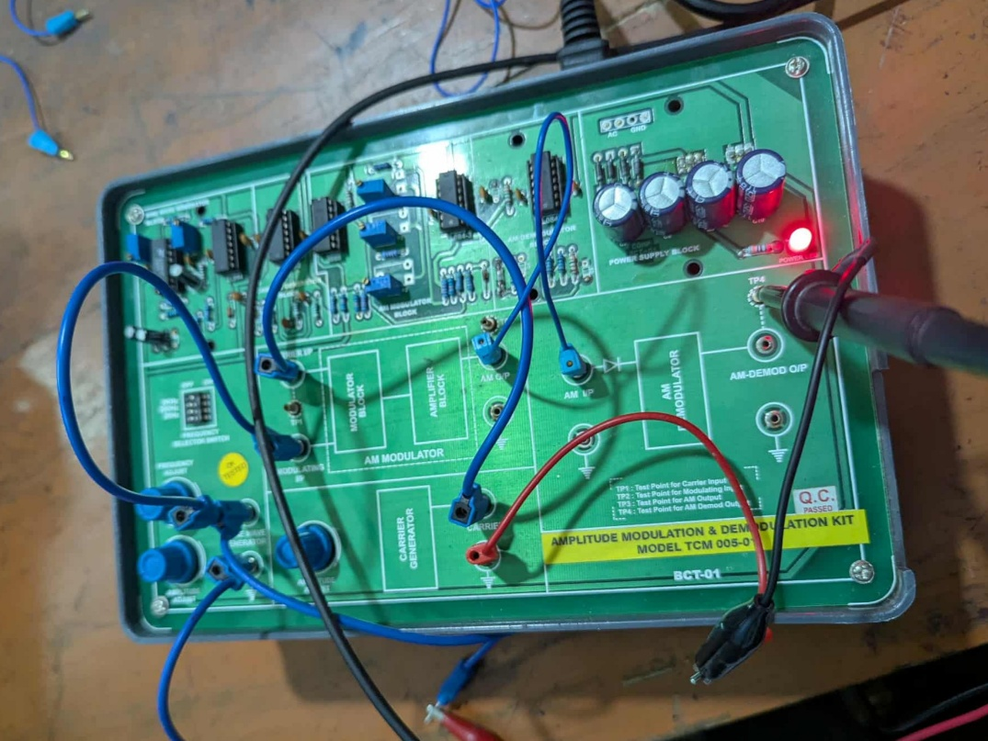

Procedure:

1. Input Signal Generation:
- A sinusoidal message signal (~2.15 kHz) is generated using the function generator. This signal is fed into the AM modulator block as the baseband input.
2. Carrier Signal Generation:
- A higher-frequency sine wave (~100–150 kHz typically but appears similar here due to time base settings) is used as the carrier.
3. Amplitude Modulation:
- The message and carrier signals are combined to produce an AM signal. This modulated signal is sent to the transmission line.
4. Demodulation:
- The AM signal is fed into the demodulator circuit. The original message signal is recovered and analyzed.

Output:

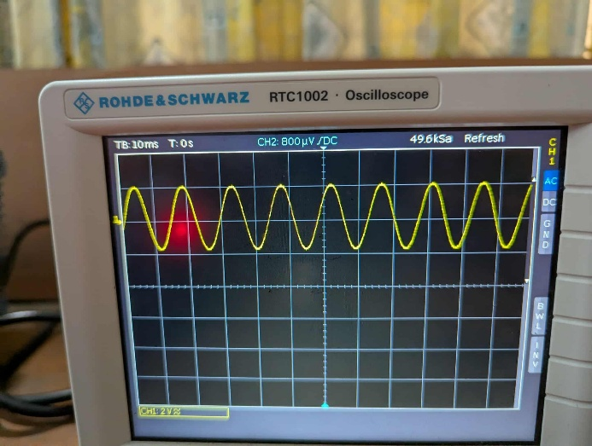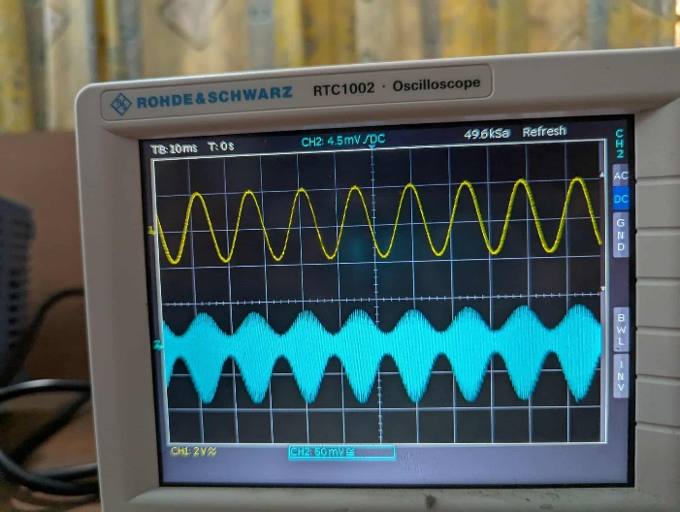
Figure-01 Figure-02

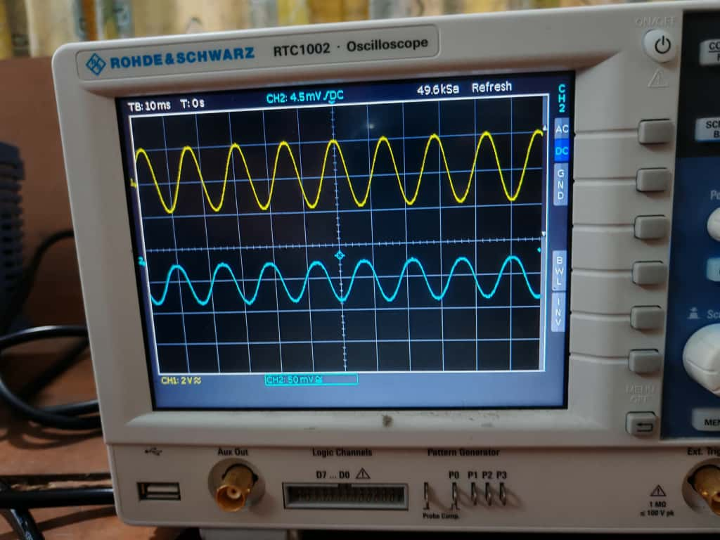
Figure-03

Precautions:
- Preventing Overmodulation
- Set Frequencies Correctly
- Properly adjust the probes of the oscilloscope

Conclusion:
This experiment illustrates that AM is a foundational technique in radio broadcasting. A baseband signal's low power prevents it from traveling far, an issue compounded by attenuation over distance, external noise, and environmental factors. Therefore, boosting the signal's strength is a prerequisite for long-range communication.

2.Experiment name:
Analog to Analog Conversion using Frequency Modulation (FM) and Demodulation

Objectives:
- This experiment was about frequency modulation.
- We made an FM signal using a carrier and a message wave, then analyzed it, sent it through a test channel, and finally recovered the original signal.
- We used an oscilloscope the whole time to watch and compare the signals to make sure the modulation and demodulation worked correctly.

Theory:
Frequency modulation (FM) encodes information by varying a carrier wave's frequency based on the message signal's amplitude, while the carrier's amplitude stays constant. The modulation index dictates how much the frequency shifts. This method requires a wider bandwidth than AM, but this trade-off provides significantly better noise resistance and higher fidelity, making it ideal for high-quality audio broadcasting.
FM generally requires a wider bandwidth compared to amplitude modulation. However, this trade-off provides better resistance to noise and interference, making FM especially suitable for high-fidelity audio transmissions, such as those used in commercial radio broadcasting.

Pin connections:

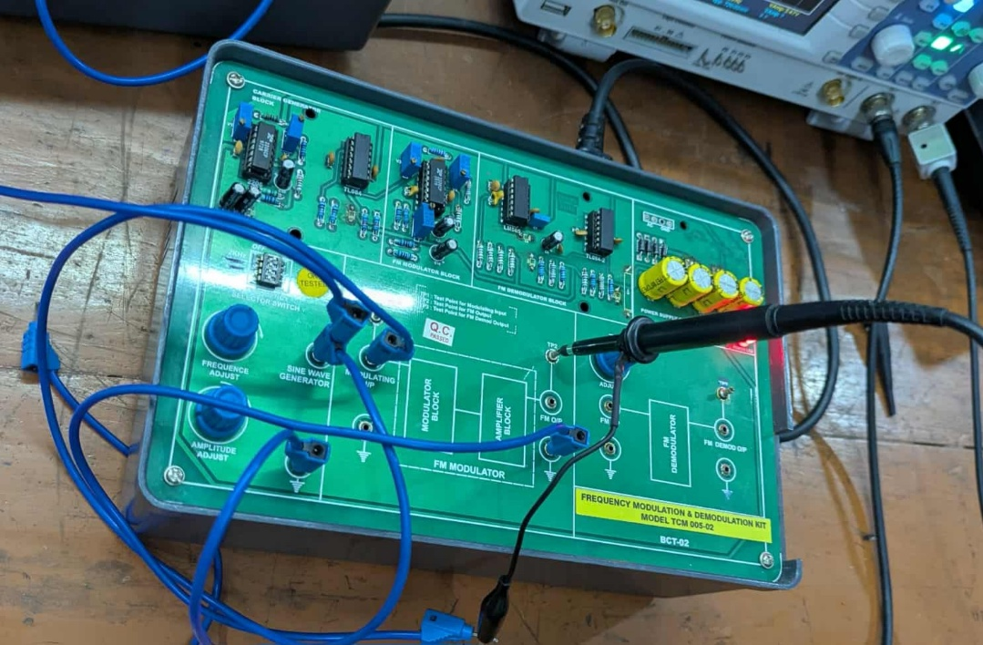

Procedure:
- Input Signal Observation:
- Two input signals with frequencies of 1 kHz and 100 kHz were generated using the function generator.
- Both signals were observed on the oscilloscope, showing stable waveforms without distortion.
- Modulation Process:
- After modulation, the input signals were combined with their respective carrier waves.
- The oscilloscope displayed clear modulated waveforms, highlighting the successful embedding of input signals into carrier frequencies.
- Demodulation Process:
- The multiplexed signal was passed through the demodulator circuit to separate the original input signals.
- Low-pass filters were used to recover the input frequencies accurately.
- The oscilloscope confirmed that the signals matched their original form.
- Final Output Signal:
- The final reconstructed signals were amplified and displayed on the oscilloscope.
- The waveforms were consistent with the original input signals, indicating a high level of accuracy in the demodulation process.
- Any observed noise or distortion was negligible.

Output:

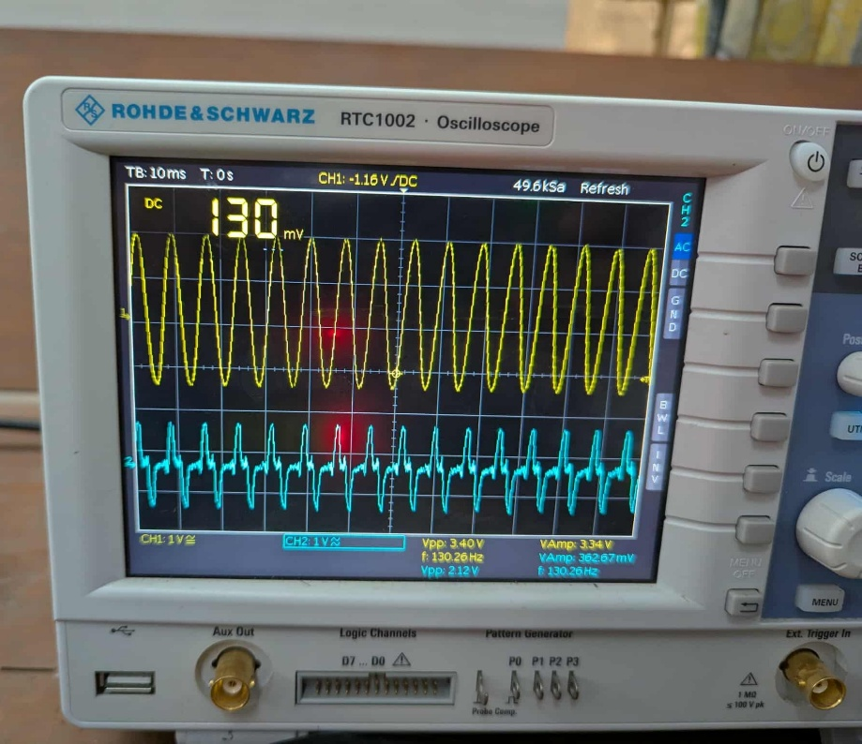

Precautions:
- Maintain Correct Frequency Ratio
- Avoid Over-Deviation (Distortion)
- Tune the Demodulator
- Connect the oscilloscope’s probe properly to see the signal.

Conclusion:
This laboratory exercise effectively illustrated the fundamental principles of frequency modulation and demodulation through hands-on implementation. The successful generation, transmission, and recovery of the modulated signal validated FM's practical application in communication systems where noise immunity is crucial, such as in FM radio broadcasting. While the experiment confirmed FM's advantages, it also highlighted the importance of precise circuit design and proper component selection to maintain signal integrity throughout the modulation-demodulation chain.

